Synthesis hydrotalcite bead by coprecipitation on SiO₂ core to remove arsenide in aqueous solution
Hao Thi Le *, Bich Thuy Ly*, Le Thu To*
* Hanoi University of Science and Technology
Keywords: Hydrotalcite bead; arsenic, water treatment
Introduction
Arsenic contamination is a serious problem in several areas of Asia, including Vietnam. Hydrotalcite (HT) has been demonstrated as a high potential material in removing of contaminants in water. However, HT is existed in power form; therefore, it is necessary to synthesize HT bead to be able to apply in treatment system. The synthesis bead must have sufficient physical strong characteristic to work inside the treatment system but also need to keep the adsorption capacity of HT at high level. Shell-core structures were chosen for this research to take advance of strong physical characteristic of core and high adsorption capacity of the shell HT. The main challenges of synthesis were to make a strong link between the core and the shell and to maintain the high adsorption capacity of the shell. In this research we combinedly applied the two reseaches of Yi Du et al (2009) (on fabricate of HT coating on ion exchange resin) and of Jiang et al (2014) (on fabrication of HT coating onto nanosized SiO₂) to coprecipitate HT on synthesized SiO₂ bead of 2 mm in diameter. The HT had formula of [Mg(II)₆Fe(III)₂(OH)₁₆]²⁺[CO₃²⁻].mH₂O, which had been previously demonstrated to have good capacity to remove arsenide (As(III)). Affected factors on each step of this fabrication process were evaluated to find a good HT bead on removal As(III).
Material and Methods

Synthesis SiO₂ core
Two gram sodium alginate was dissolved in 20 mL distilled water and incubated in a water-bath incubator at 80ºC for completely dissolving before adding 5 gram of SiO₂ with comprehensively stirring. The mixture solution was let cooling to room temperature then was taken into a syringe and dropped out one by one into CaCl₂ 10% solution to create bead as spherical form with diameter of around 2 mm. Then, SiO₂ beads were dipped into CaCl₂ 10% for 24 hours before washing with distilled water for 3 times and drying at 105ºC in 24 hours (Figure 1a). Alginate ratio was determined from pre-experiment to find the minimum ratio that the bead is still stable after sharing in 100 rpm in 180 min.

Precipitation of HT on SiO₂
SiO₂ core with the weight of 0.5 g; 1 g and 1.5 g were added separately in 50 mL mixture Mg(NO₃)₂.6H₂O (1M) and Fe(NO₃)₃.9H₂O (1M) and soaked in those mixture for 24 hour. Then the soaked SiO₂ beads were put into mixture of NaOH and Na₂CO₃ (1M, 50mL) and soaked in 1 hour. The soaked beads were washed 3 times by distilled water and dried at a temperature of 105ºC. The bead with 0.5g; 1g; 1.5g added SiO₂ were named as SO-MF1; SO-MF2; SO-MF3, respectively (Figure 1b). The two soaking periods were determined from previous experiment, showing no clear difference among different soaking period from 1 hour to 24 hour.

Adsorption experiment
Batch equilibrium sorption experiments were carried out in 50 mL Erlenmeyer flasks containing As(III) solutions at 25ºC and shaking speed at 100 rpm. For the experiment to investigate the effect of time, initial As(III) concentration of 500 µg/l was used at time interval of 15; 30; 60; 90; 240; 360; 1080 min. For the experiment to investigate the isothermal curve, solid to liquid ratio of 25 g/L, adsorption time of 360 min, and initial As(III) concentration of 1, 20, 50, 100, 200, 300 mg/L were applied.

Analysis
As(III) analysis was proceeded by GC-MS Perkin Elmer.
XRD analysis was carried by D8 Advance- Bruker XRD
Results and Conclusions
Characteristics of material
The results of X-ray diffraction analysis showed SiO₂ represented peaks (d = 2.62; 3.347; 2.465; 2.28; 2.132; 1.818; 1.664; 1.154; 1.153; 1.377) with high intensity and HT represented peaks (d = 7.821; 2.31; 1.664; 1.285) with lower intensity. The low intensity of HT peak may be because the HT layer was very thin comparing with SiO₂ core. However, this result demonstrated the HT was successful co-precipitated in SiO₂ core.
Effect of adsorption time on As(III) removal
The effect of adsorption time (Figure 3) showed that all HT beads reached the state of nearly full saturation after 6 h and after 18 h, the saturation can be considered to be obtained. The removal capacity for SO-MF1; SO-MF2; SO-MF3 were 74.8 / 80.5; 71.7 / 76.9; 67.9 / 73.3 % for 6 / 18 hrs. More than 90% of removal efficiency was obtained at 6 hour adsorption interval. Six-hour interval was chosen for next experiment. Nhat Ha et al (2016) reported that 8 hours were required to reach equilibrium when a HT bead named poly(MgFe) was used as an adsorbent to remove arsenate (As(V)).
The saturation period of HT bead was much longer than that of HT powder (< 30 min). This fact suggests that, whereas the adsorption sites of powder HT is ready to access by As(III), it takes longer time for As(III) to access adsorption site of HT bead. The low adsorption capacity of SiO₂ (<10%) showed the clear effect of HT layer of HT coating bead on As(III) removal.
The maximum adsorption capacity of synthesis HT were followed the order of SO-MF1> SO-MF2> SO-MF3 (2.7 > 2.3 > 2.1 mg/g). The data were fitted well with Langmuir model as summarized in Table 1. The higher ratio of HT initial chemical amount on SiO₂ the higher adsorption capacity. A further incensement in initial chemical amount is predicted to increased adsorption capacity of HT bead. These adsorption capacities were higher than adsorption capacities of the HT adsorbent poly(LDH) on As(V) (1.73 mgAs/g for poly(MgAl) and 1.64 mgAs/g for poly(MgFe) ) by Nhat Ha et al (2016).
In short, HT bead on SiO₂ support had been successful synthesized. The HT bead (SO-MF1) had adsorption capacity for As(III) of 2.7 mg/g. A higher adsorption capacity is predicted to be obtained by increasing the ratio of soaking initial HT chemicals on SiO₂. However, a low efficiency of HT crystal forming on the core is the disadvantage of this method reframing the application of higher amount of initial HT chemical.
Table 1. Langmuir model parameters for As(III) adsorption on SO-MF
Absorbent | Langmuir
Absorbent | k (L/mg) | q_{m} (mg/g) | R²
SO-MF1 | 0.040 | 2.7 | 0.977
SO-MF2 | 0.606 | 2.3 | 0.994
SO-MF3 | 0.042 | 2.1 | 0.998

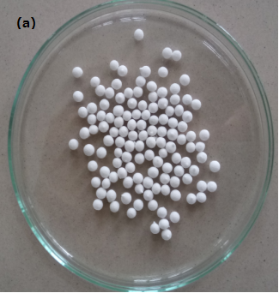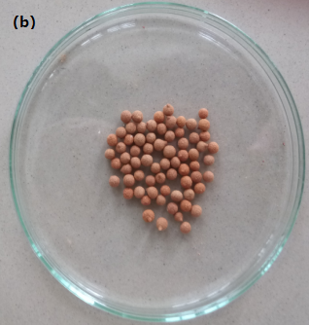
Figure 1: Synthesis bead: a) SiO₂ support; b) HT covered SiO₂
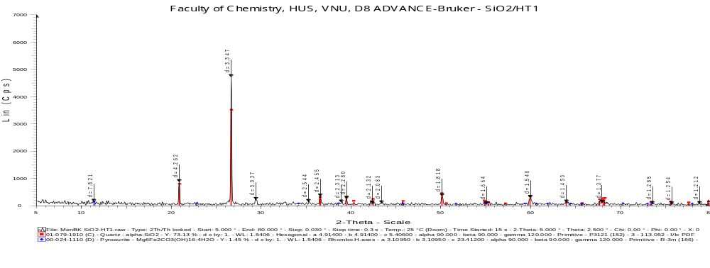
d=4.262
d=3.347
d=7.821
d=3.037
d=2.544
d=2.083
d=1.664
d=1.286286
d=1.818
d=1.540
d=1.453
d=1.212
Figure 2. XRD pattern of SO-MF

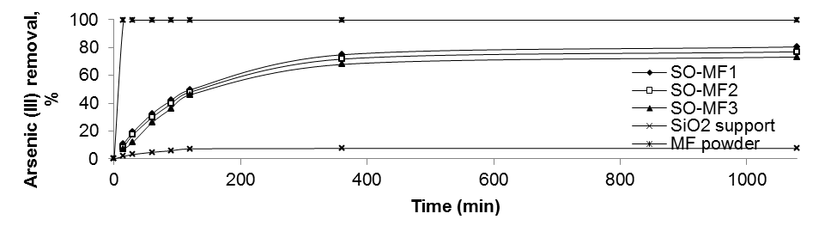
Figure 3. Effect of time on As(III) removal
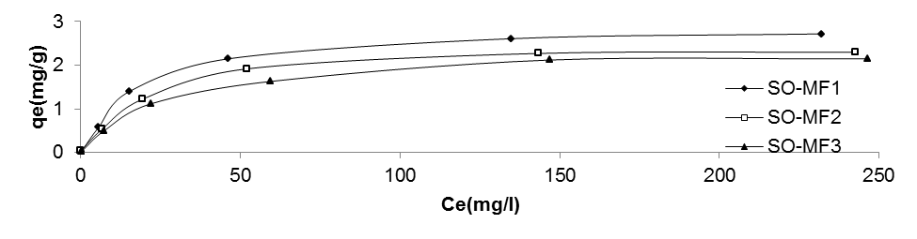
Figure 4. Isotherm sorption curve for As(III) adsorption on SO-MF1, SO-MF2, SO-MF3
References
Jiang, Shu-Dong, Bai, Zhi-Man, Tang, Gang, Song, Lei, Stec, Anna A, Hull, T Richard, Hu, Yuan and Hu, Wei-Zhao (2014), Synthesis of Mesoporous Silica@Co–Al Layered Double Hydroxide Spheres: Layer-by-Layer Method and Their Effects on the Flame Retardancy of Epoxy Resins. ACS Applied Materials & Interfaces., 6 (16), 14076-14086.
Ho Nguyen Nhat Ha, Nguyen Thi Kim Phuong, Tran Boi An, Nguyen Thi Mai Tho, Tran Ngoc Thang, Bui Quang Minh and Cao Van Du (2016), Arsenate removal by layered double hydroxides embedded into spherical polymer beads: Batch and column studies, Journal of Environmental Science and Healt., 1532-4117.
Yi Du, Gang Hu and Dermot O’Hare (2009), Nucleation and growth of oriented layered hydroxides on polymer resin beads. J. Mater. Chem., 19, 1160–1165.

